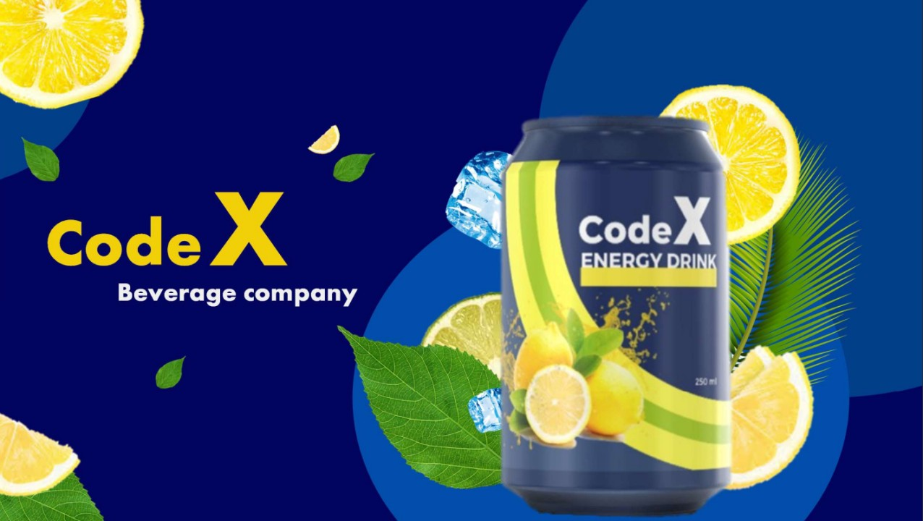

**Survey Analysis Report**

**Codex India**

Syeda Sarah Mashhood

14th October 2023

**Executive Summary**

CodeX, a well-known German beverage company, recently introduced its energy drink in India. They conducted a survey in ten major Indian cities, gathering responses from 10,000 people. The goal of this analysis is to turn the survey data into useful insights for their marketing, market share, and product development strategies.

In this report, we'll explore what the survey revealed and how it can guide CodeX in becoming a successful player in the Indian market. We'll look at what people like and want, helping CodeX make smart decisions for their brand and products. By understanding the demographics, consumption habits, preferences, and perceptions of their potential customers, CodeX can tailor their strategies for maximum impact and growth in this new market.

Table of Contents

1. **I**ntroduction 4

Background and Objectives: 4

Scope of Analysis: 4

Methodology: 4

2. Data Cleaning and Preprocessing 4

3. Primary Insights 4

i. Demographic Analysis: 4

ii. Geographic Distribution: 4

iii. Age Group Composition: 5

a) Demographic Insights 6

b) Consumer Preferences: 8

c) Competition Analysis: 9

d) Marketing Channels and Brand Awareness: 11

e) Brand Penetration: 12

f) Purchase Behavior of Energy Drink Consumers 16

g) Product Development: 20

4.Recommendation……………………………………………………………………………………………………………………………….23

**1.** Introduction

## Background and Objectives:

CodeX, a German beverage company, launched its energy drink in 10 Indian cities a few months ago. The Marketing team's mission is to enhance brand awareness, capture market share, and drive product development. To achieve these goals, a survey was conducted in the target cities, collecting responses from 10,000 participants.

## Scope of Analysis:

This analysis aims to provide insights and recommendations based on the survey data. It includes an exploration of demographic data, consumption habits, awareness, product experience, competitor analysis, ingredients and health concerns, marketing, pricing, and availability.

## Methodology:

The analysis uses data analytics tools and techniques to extract valuable insights from the survey data. Visualizations and charts are employed to illustrate key findings.

2. Data Cleaning and Preprocessing

Data cleaning and preprocessing were essential to ensure data quality. There are three sheets available for dataset (facts and dimensions). Firstly, these sheets are combined together so that analysis can be done. There are no missing values and duplicate values in the dataset.

**3.** Primary Insights

The primary insights section is a comprehensive analysis of survey data. It includes an examination of demographics, consumption habits, brand awareness, product experience, competitor analysis, health concerns, marketing channels, pricing, and availability. Key findings include:

### Demographic Analysis:

The survey's demographic composition reveals significant insights about the target audience. Among the respondents, the majority identify as male (60%), followed by female respondents (35%), with a smaller percentage identifying as non-binary (5%).

### Geographic Distribution:

The survey was conducted in 10 distinct Indian cities, covering a wide geographical range. However, it is noteworthy that a considerable proportion of respondents are concentrated in specific urban centers, particularly Bangalore, Hyderabad, Mumbai, Chennai, and Pune. These cities constitute a key focus for market entry strategies.

### Age Group Composition:

The analysis indicates that the dataset comprises a diverse age group distribution. Over half of the respondents (55%) belong to the 19-30 age group, a prime target for energy drink consumption. Additionally, 21% of the respondents fall within the 31-45 age bracket, reflecting a significant portion of middle-aged individuals who are also relevant to CodeX's market objectives.

This detailed demographic analysis provides a foundation for tailoring marketing strategies and targeting specific demographics, such as young adults and middle-aged individuals.

## Demographic Insights

**Gender-Based Energy Drink Preferences**

Gender variations exist in the dataset, but preferences for energy drink consumption are remarkably consistent. Roughly 35% of respondents from each gender category opt for consuming energy drinks 2-3 times a week, with daily consumption at about 12-13%. Surprisingly, approximately 19% of respondents across all genders indicate rare consumption. This uniformity underlines the broad appeal of energy drinks and emphasizes the need for marketing strategies accommodating diverse consumption patterns. These insights offer direction for tailored campaigns and product development.

**Age-Based Energy Drink Preferences**

The dataset exhibits variations in age group distribution, which in turn influence preferences for energy drink consumption. Remarkably, similar consumption trends are observed across various age groups. About 35% of respondents in each age category prefer to consume energy drinks 2-3 times a week, indicating a consistent pattern. Additionally, daily consumption is prevalent, with a range of approximately 12-14%, except for the 46-65 age group. Conversely, respondents who consume energy drinks rarely comprise a substantial proportion, with figures ranging from 18% to 20%. These uniform preferences for energy drink consumption among different age groups emphasize the universal appeal of such beverages and underscore the importance of tailored marketing strategies to accommodate these varied consumption habits. These insights can guide marketing campaigns and product development initiatives that align with the diverse preferences across age groups.

**Marketing Channel Preferences among Youth (15-30):**

Among the youth demographic (aged 15-30), the survey data highlights clear preferences for specific marketing channels. Online ads emerge as the primary choice, effectively reaching 48% of this age group. In contrast, TV commercials maintain a noteworthy presence, with 26% of youth respondents engaging with this channel. Notably, print media appears to play a relatively minor role in connecting with this audience. This insight underscores the importance of emphasizing online advertising strategies for targeting the youth demographic, while also acknowledging the limited impact of print media. These findings offer valuable guidance for optimizing marketing efforts towards the youth segment.

## Consumer Preferences:

**Preferred Ingredients in Energy Drinks**

The data reveals that caffeine is the most preferred ingredient in energy drinks, chosen by 39% of respondents, followed by vitamins at 25%. In contrast, Guarana is the least preferred ingredient. Remarkably, these ingredient preferences remain consistent across different age groups and genders. This uniformity in ingredient preference suggests that consumers across various demographics prioritize caffeine and vitamins in their choice of energy drinks. These insights can guide product development and marketing strategies to align with the widespread preference for specific ingredients.

**Preferred Energy Drink Packaging**

In terms of packaging preferences, the majority of respondents, at 40%, favor compact and portable cans, emphasizing the need for convenient and on-the-go options. Innovative bottle designs also garner significant interest, with 30% of respondents expressing a preference for this category. Notably, 10% of respondents indicate a preference for eco-friendly packaging. These insights underline the significance of user-friendly, portable packaging solutions in the energy drink market. They also suggest that innovative bottle designs have the potential to resonate with a considerable portion of the consumer base.

## Competition Analysis:

**Current Market Leaders**

The survey data points to clear market leaders in the energy drink segment. Notably, Cola-Coka emerges as the dominant market leader, commanding a substantial 25% market share. Following closely is Bepsi, with a significant 20% market share. In contrast, Codex holds the fifth position, with a 10% market share. These findings shed light on the competitive landscape in the energy drink market, highlighting the strong presence of well-established brands. Codex, while holding a smaller market share, has the potential for growth and should explore strategies to enhance its **position.**

**Primary Reasons for Choosing Other Brands**

The primary factors influencing respondents' choice of other energy drink brands are brand reputation and taste preference. These two elements play a pivotal role in consumer decision-making, highlighting the significance of a brand's image and the sensory experience it provides. Understanding the importance of these aspects can inform Codex's strategies for enhancing its brand reputation and taste appeal to effectively compete in the market.

## Marketing Channels and Brand Awareness:

**Online Ads and TV Commercials**

Among respondents who are aware of Codex, the distribution of marketing channels highlights the prominent roles played by online ads and TV commercials. These channels appear to be instrumental in building brand awareness and reaching the target audience. This insight underscores the effectiveness of online advertising and television marketing strategies in promoting Codex within the consumer market. Understanding the reach of these channels can guide the allocation of resources and efforts in promoting the brand further.

**Marketing Channels and Brand Awareness among Codex Customers**

An analysis of Codex customers reveals a similar trend in marketing channel distribution, with online ads and TV commercials playing pivotal roles. These channels remain highly influential in engaging Codex's existing customer base, underscoring their continued significance in building brand loyalty and awareness. Recognizing the effectiveness of these channels among Codex customers can help optimize marketing strategies and maintain customer engagement.

## Brand Penetration:

Among respondents who are familiar with Codex, the brand perception is notable. A significant proportion, 58%, holds a neutral perception, indicating a potential opportunity for brand enhancement. Additionally, 24% of respondents maintain a positive perception of Codex. These insights reflect the existing brand image and its potential for improvement. Recognizing the neutral sentiment among a majority of respondents can guide strategies for strengthening Codex's brand identity and resonating with its target audience.

An analysis of Codex's existing customers reveals that brand perception remains relatively consistent. The majority of customers, 58%, maintain a neutral perception, while 24% hold a positive view of the brand. This consistent brand perception suggests that Codex's existing customer base continues to have a balanced outlook. Understanding this stability in perception can guide efforts to maintain customer satisfaction and reinforce brand loyalty.

**Product Experience: Rating Distribution**

The distribution of ratings provided by respondents indicates a central tendency toward ratings of 3 and 4. This suggests that most respondents have a moderately positive to good product experience with Codex's energy drink. Understanding this distribution can help Codex identify areas for potential product improvement and enhance customer satisfaction.

.

When considering Codex's customer base, the distribution of ratings is notably more favorable. The average rating provided by Codex customers stands at 3.27, indicating a relatively positive product experience. This suggests that Codex has been successful in maintaining customer satisfaction and delivering a favorable product experience. Understanding this improved rating distribution among existing customers can guide strategies for enhancing overall customer loyalty and attracting new customers.

**Brand Awareness by City**

The charts reveal the percentage of respondents in various cities who are aware of the brand (depicted in red) and those who are not aware (depicted in blue). This information provides valuable insights into the geographical distribution of brand awareness. It is evident that certain cities have a higher level of awareness, while others may require more focused efforts to increase brand recognition. Understanding these variations in brand awareness can guide targeted marketing strategies and resource allocation to maximize Codex's market presence.

A notable observation emerges from the data, where a portion of Codex customers has selected Codex as their current brand, despite not having heard about the brand before or tried it previously. These charts depict the distribution of Codex customers who exhibit both brand awareness and product trial. This suggests that Codex has successfully attracted and retained a segment of customers who were previously unfamiliar with the brand. Understanding this unique customer segment can help tailor marketing and product development strategies to maintain their loyalty and attract similar customers in the future.

## Purchase Behavior of Energy Drink Consumers

The data indicates that the majority of energy drink consumers prefer to purchase their beverages from supermarkets, accounting for 45% of the responses. Additionally, online retailers play a significant role in the purchase behavior, with 25% of respondents choosing this option. Interestingly, 15% of consumers opt to buy energy drinks from gyms and fitness centers. Understanding these preferences can help Codex align its distribution and marketing strategies to cater to the most preferred purchase channels of its target audience.

**Typical Consumption Situations for Energy Drinks**

The data reveals that energy drinks are commonly consumed in specific situations. Notably, 45% of respondents consume them during sports and exercise, while 32% turn to energy drinks when studying or working late. Additionally, 15% of consumers enjoy these beverages during social outings and parties. Recognizing these typical consumption situations can guide Codex in tailoring its marketing and product positioning to align with the preferences and needs of its target audience.

**Limited Edition Packaging**

The data does not provide substantial insights regarding the demand or need for limited edition packaging. Further analysis or research may be required to draw meaningful conclusions in this regard. Codex should consider conducting targeted studies or surveys to assess the potential impact of limited edition packaging on customer preferences and purchasing decisions.

Among Codex users, a notable 43% express an interest in limited edition packaging. This indicates a potential opportunity for Codex to enhance its product offerings by incorporating limited edition packaging, which can be an effective strategy to attract and retain customers. Understanding this demand for unique and collectible packaging can guide Codex in creating appealing product variations to cater to customer preferences and potentially boost sales and brand loyalty.

**Preferred Price Range for Energy Drinks**

The data indicates that the most preferred price range for energy drinks among respondents is in the 50-99 and 100-150 categories. Understanding the price points that resonate with customers can assist Codex in pricing its products competitively and effectively, ensuring that they align with the budget and expectations of its target audience.

.

**Price Range Preferences of Codex Customers**

An intriguing finding from the data is that the distribution of price range preferences among Codex customers is relatively consistent. This suggests that Codex has successfully attracted customers across different price range categories, potentially due to a well-balanced pricing strategy. Codex should continue to monitor and adjust its pricing to maintain this equilibrium and cater to a diverse customer base effectively.

## Product Development:

**Reasons for Not Trying Codex Energy Drink**

The data reveals that there are various reasons why respondents have not tried Codex energy drink. Notably, four reasons stand out for further investigation:

* Local Unavailability
* Health Concerns
* Lack of Interest in Energy Drinks
* Unfamiliarity with the Brand

These specific reasons warrant additional research and consideration for Codex in its product development and marketing strategies to address these barriers effectively and potentially expand its customer base.

**Key Observations and Recommendations:**

**Availability:** Availability of Codex is a significant concern, with 56% of respondents not having heard about the brand. It's crucial for Codex to work on expanding its local presence to address this issue effectively.

**Unfamiliarity:** Unfamiliarity with the brand is another major challenge, as noted by the 56% who have not heard of Codex. Codex should invest in branding and marketing efforts to improve brand recognition and awareness.

**Perceptions**: A noteworthy 22% of respondents consider energy drinks dangerous, while 26% are uncertain about their effects. Codex should focus on educating consumers about the safety and benefits of their product, potentially through clear and transparent labeling and marketing.

**Health Concerns**: Approximately 23% of respondents express health concerns regarding energy drinks. Codex should consider catering to this market segment by developing products with organic and natural ingredients, reduced sugar content, and a focus on health benefits.

**Average Taste Experience:** Across all the brands in the survey, the average taste experience falls in the range of approximately 3.2 to 3.3. This indicates that respondents, on average, have a neutral to slightly positive perception of the taste of energy drinks available in the market. Codex should aim to meet or exceed this average to provide a competitive taste experience for its customers.

1. **Recommendations**

* **Targeted Marketing:**

Given the strong preference for online ads and TV commercials, CodeX should focus its marketing efforts on these channels. This is particularly effective in reaching the youth (aged 15-30), who are a significant consumer group. Invest in creative and engaging online advertising campaigns to capture the attention of potential customers.

* **Product Development:**

Address the issue of local unavailability. Work on expanding distribution and ensuring that the product is easily accessible to consumers in all target cities. Respond to health concerns by introducing healthier, more natural ingredients and reducing sugar content in the energy drink. Focus on the taste and flavor of the product to improve its overall rating among consumers. Continuous refinement in this aspect can lead to higher customer satisfaction.

* **Brand Perception and Awareness:**

Enhance the brand's perception by leveraging positive reviews and testimonials from customers. Encourage satisfied customers to share their experiences on social media and other platforms. Consider collaborating with influencers or celebrities who align with the brand's image to boost awareness and credibility.

* **Pricing and Availability:**

Offer competitive pricing, especially within the preferred price ranges of 50-99 and 100-150. This will attract a broader consumer base. Ensure the product is available in various types of retail outlets, including local stores, supermarkets, and online retailers, to reach consumers at multiple touch points.

* **Limited Edition Packaging:**

Respond to the 43% of Codex users who express interest in limited edition packaging. Create limited-time special packaging designs to appeal to this segment of the market.

* **Customer Engagement:**

Establish a feedback mechanism to encourage customers to express their opinions on the product. This can help identify areas for improvement and build brand loyalty. Offer promotions, discounts, or loyalty programs to incentivize repeat purchases.

* **Competitive Analysis:**

Keep a close eye on the market leaders, Cola-Coka and Bepsi, to understand and adapt to their strategies. Regularly survey consumers to stay updated on their preferences and expectations and adapt your product and marketing strategies accordingly.

* **Target Audience:**

Tailor marketing campaigns to specific age groups and cities where awareness and preference for the brand are lower, such as Delhi and Kolkata.

* **Influencer Collaboration:**

Collaborate with a local celebrity or influencer who resonates with the brand's target audience (mainly sportspersons). This influencer can endorse the product, increasing brand credibility and visibility.

These recommendations are designed to help CodeX establish a strong presence in the Indian market and to cater to the preferences and expectations of its potential consumers. It is crucial for CodeX to continuously gather feedback, analyze market dynamics, and adapt to changing consumer behaviors to remain competitive and successful.